केन्द्रीय विद्यालय बी एस एफ रामगढ़ (ग्रीष्मकालीन अवकाश गृह कार्य)
विषय – हिन्दी ,कक्षा – 6
निर्देश:-सभी विद्यार्थी यह कार्य ग्रीष्मकालीन अवकाश में करेंगे।
1.चिड़िया के अलावा आपको कौन – सा पक्षी अच्छा लगता है ? उसका चित्र बनाइए |
2.आपके आसपास खाने में कौन – कौन से व्यंजन प्रचलित है ? उनकी सूची बनाइए |
3.अपने बचपन की कोई मनमोहक घटना को विस्तार से लिखिए|
4.केशव और श्यामा की तरह आपको किसके बारे में जानने की इच्छा है और क्यों ?
5.अपनी बड़ी बहन को गर्मी की छुट्टियां बिताते हुए पत्र लिखिए |
6. बाल रामकथा के आधार पर राम–लक्ष्मण की विशेषताएं लिखिए|
7. सर्वनाम शब्दों का प्रयोग करते हुए 5 वाक्य बनाइए |
8. दस पृष्ठ सुलेखन कीजिए |

केन्द्रीय विद्यालय बी एस एफ रामगढ़ (ग्रीष्मकालीन अवकाश गृह कार्य)
विषय – हिन्दी ,कक्षा – 7
निर्देश:-सभी विद्यार्थी यह कार्य ग्रीष्मकालीन अवकाश में करेंगे।
1.शहरीकरण से पर्यावरण किस प्रकार प्रभावित होता है 10 पंक्तियां लिखिए|
2.सावन,कार्तिक,फाल्गुन में कौन-कौन से त्योहार आते हैं किसी एक पर अनुच्छेद लिखिए
3.आपके आसपास पर्यटक स्थलों की जानकारी एकत्रित करके लिखिए|
4.नदियों से हमें क्या क्या लाभ होते हैं 10 पंक्तियां लिखिए|
5.आपके आसपास में गंदगी होने पर सफाई के लिए नगरपालिका अध्यक्ष को एक प्रार्थना पत्र लिखिए।
6. बाल महाभारत की कथा के आधार पर भीष्म की विशेषताएं लिखिए |
7. पाठ्यपुस्तक से द्वंद समास के 10 उदाहरण खोजकर लिखिए|
8. दस पृष्ठ सुलेखन कीजिए

केन्द्रीय विद्यालय बी एस एफ रामगढ़ (ग्रीष्मकालीन अवकाश गृह कार्य)
विषय – हिन्दी ,कक्षा – 8
निर्देश:-सभी विद्यार्थी यह कार्य ग्रीष्मकालीन अवकाश में करेंगे।
1.वसंत ऋतु में आने वाले त्योहारों की सूची बनाकर किसी एक पर अनुच्छेद लिखिए |
2 आपके मनपसंद कविता की कोई चार पंक्तियां लिखिए |
3.आपको छुट्टियों में किसके घर जाना अच्छा लगता है और क्यों ?
4.आज भी बाजार में हाथ से बनी हुई चीजें मिलती है उनकी सूची बनाइए|
5.यदि बस जीवित प्राणी होती और वह बोल सकती तो वह अपना कष्ट किन शब्दों में व्यक्त करती
6.किसी यात्रा में जाते समय की तैयारी का वर्णन अपने शब्दों में लिखिए|
7. अपने मित्र को जन्मदिन की शुभकामना देते हुए एक पत्र लिखिए|
8. दस पृष्ठ सुलेखन कीजिए |

केन्द्रीय विद्यालय बी एस एफ रामगढ़ (ग्रीष्मकालीन अवकाश गृह कार्य)
विषय – हिन्दी ,कक्षा – 9
निर्देश:-सभी विद्यार्थी यह कार्य ग्रीष्मकालीन अवकाश में करेंगे।
1.किसान के जीवन पर 100 शब्दों में एक अनुच्छेद लिखिए |
2 अपने क्षेत्र में होने वाली फसलों की जानकारी एकत्रित करके लिखिए |
3.अपनी किसी एक यात्रा का संक्षिप्त वर्णन लिखिए|
4 कबीर दास जी के कौन से पद आपको अच्छे लगे हैं और क्यों उनको लिखिए|
5.किसी समाज सुधारक पर एक लेख लिखिए |
6.किसी एक स्वतंत्रता सेनानी का सचित्र वर्णन कीजिए |
7.अपने बड़े भाई की शादी में शामिल होने के लिए तीन दिन की छुट्टी हेतु प्राचार्य को एक पत्र लिखिए |
8.अपनी पाठयपुस्तक से उपसर्ग एवं प्रत्यय वाले 10–10 शब्द खोजकर लिखिए |
9. बीस पृष्ठ सुलेखन कीजिए |

केन्द्रीय विद्यालय बी एस एफ रामगढ़ (ग्रीष्मकालीन अवकाश गृह कार्य)
विषय – हिन्दी ,कक्षा – 10
निर्देश:-सभी विद्यार्थी यह कार्य ग्रीष्मकालीन अवकाश में करेंगे।
1.गोपियों की जगह आप होते तो अपना तर्क किस प्रकार देते?
2.किसी एक स्वतंत्रता सेनानी का सचित्र वर्णन कीजिए |
3. गोस्वामी तुलसीदास का साहित्यिक जीवन परिचय लिखिए |
4. अवधी भाषा के किसी एक कवि का सचित्र वर्णन कीजिए |
5.सूरदास जी की प्रमुख रचनाओं के बारे में संक्षेप में लिखिए |
6.वर्तमान समय में कोरोना की भयावह स्थिति पर एक अनुच्छेद लिखें |
7.राम और लक्ष्मण की तीन –तीन विशेषताएं लिखिए |
8.आप से किसी महापुरुष की मूर्ति लगाने के लिए कहा जाए तो आप
किसकी मूर्ति लगाएंगे, और क्यों ?
9. बीस पृष्ठ सुलेखन कीजिए |

KENDRIYA VIDYALAYA BSF RAMGRH
SUMMER VACATION HW (2022- 2023)
Class- 6
Subject- Maths

- Fill in the blanks:
- If the product of two whole numbers is zero then one of them will be_____ .
- Every natural number except ______ has a predecessor.
- If we add the number _____ to the collection of natural numbers, we get the collection of whole numbers
- Place value of 7 in ‘3627992’ is _________.
- Expanded form of 3920671 is __________.
- Number name of 63728729 in Indian system of numeration is __________.
- Number name of 782678926 in International system of numeration is _________.
- ________ is the smallest whole number.
- If we add __________ to a number, we get its successor.
- 786 when estimated to the nearest tens is ______ and when estimated to the nearest hundreds is _______.

- Medicine is packed in boxes, each weighing 5kg 600g. How many such boxes can be loaded in a van
which cannot carry beyond 260kg?

- A student multiplied 1234 by 67 instead of multiplying by 76. By how much was his answer lesser than the correct answer.

- Sunny is a famous cricket player. He has so far scored 8932 runs in test matches. He wishes to complete 10,000 runs. How many more runs does he need?

- Starting from the smallest 4 digit number, write the next five numbers in the ascending order.

- Write the predecessor for the following numbers:
- 72731731
- 3932802201

- Write the successor for the following numbers:
(a) 32891210 (b) 98752122

- Write the following in roman numerals:
- 329 (b) 98 (c) 121

- Write the following in Hindu - Arabic system of numeration: (a) CCCXL (b) LXXXVI (c) CDXLVI (d) XCIX
- The canteen charge Rs. 50 for lunch and Rs. 20 for milk for each day. How much money do you spend in 4 days on these things?

- Simplify by using suitable properties (also state them ): (a) 71 x 56 + 29 x 56
- 135 x 52 + 135 x 48
- 16825 x 16825 – 16825 x 6285
- 569 x 17 + 569 x 13 + 569 x 70

- If the product of two whole numbers is 1, can we say that one or both of them will be 1? Justify through examples.

- Simplify by using suitable rearrangement:
(a) 4 x 927 x 25 (b) 250 x 60 x 50 x 8
- If you are on a diet and have a breakfast containing 150 calories, a lunch consisting of 350 calories, and a dinner consisting of 1000 calories, then find the sum of the calories consumed that day.

- At a certain school each classroom contains 32 students. How many classrooms will you need for 384 students?

- Name any five large cities in India. Find their population. Write their population in numerals and words using Indian place value chart.

- LEARN MULTIPLICATION TABLES FROM 1 TO 20.

- PROJECT WORK: Write a paragraph ( in not more than 50 words) on “RAMANUJAN - The Great Mathematician”. Write the important contributions of him .

- Note : all the students have to write solution of these questions in Mathematics homework or activity notebook separately.

Class- VII
Subject- MATHEMATICS
______________________________________________________
INSTRUCTIONS:
- Read all the questions carefully before solving. Write the
solution of questions in Mathematics Holiday notebook.
- Complete the project in neat and clear hand writing.

Questions
- When the integers 10, 0, 5, -5,-7 are arranged in descending or ascending order, then find out which of the following integers always remains in the middle of the arrangement.
(a) 0 (b) 5 (c) – 7 (d) -5

- By observing the number line, state which of the following statements is not true?

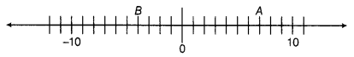
a) B is greater than -10 (b) A is greater than 0

(c) B is greater than A (d) None

- By observing the above number line, state which of the following statements is true?
(a) B is 2 (b) A is – 4 (c) S is -13 (d) B is – 4
- Next three consecutive numbers in the pattern 11, 8, 5, 2,___ ,__ ,__ are
- (a) 0, – 3, – 6 (b)-1,-5,-8 (c) – 2, — 5, – 8 (d)-1,-4,-7
- Which of the following statements is not true?
(a) When two positive integers are added, we always get a positive integer.
(b) When two negative integers are added, we always get a negative integer.
(c) When a positive integer and a negative integer are added, we always get a negative integer.
(d) Additive inverse of an integer 2 is (-2) and additive inverse of (-2) is 2.
- On the following number line value, ‘zero’ is shown by the point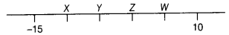
(a) X (b) Y (c) Z (d) W

- The value of 5 + (- 1) lie between
- (a) 0 and -10 (b) -2 and 10
(c) – 4 and -15 (d) – 6 and -2
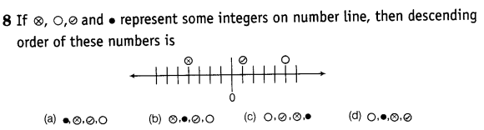
- Water level in a well was 20 m below ground level. During rainy season, rainwater collected in different water tanks was drained into the well and the water level rises 5 m above the previous level. The wall of the well is lm 20cm high and a pulley afixed at a height of 80 cm. Raghu wants to draw water from the well. The minimum length of the rope, that he can use is
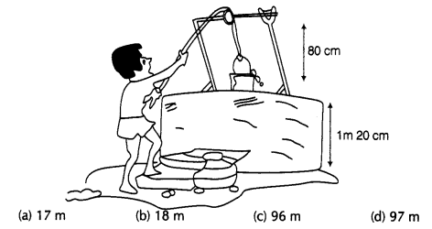

- Using number line, find:
(i) 3 × (-5)
(ii) 8 × (-2)
- Solve the following:
(i) (-8) × (-5) + (-6)
(ii) [(-6) ÷ (-3)] + (-4)
(iii) (-10) × [(-13) + (-10)]
(iv) (-5) × [(-6) - 5]
- You have ₹ 500 in your saving account at the beginning of the month. The record below shows all of your transactions during the month. How much money is in your account after these transactions?
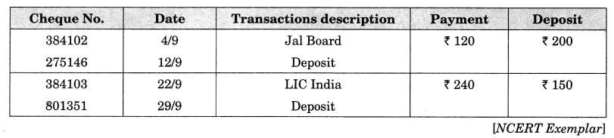
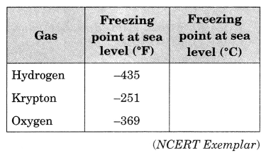
- The given table shows the freezing points in °F of different gases at sea level. Convert each of these into °C to the nearest integral value using the relations and complete the table
$C =\frac{5}{9} ( F -32)$
- Taking today as zero on the number line, if the day before yesterday is 17 January, what is the date on 3 days after tomorrow?
- Social Studies Application remembering that 1AD came immediately after 1 BC, while solving following problems take 1BC as -1 and 1AD as + 1.
(i) The Greeco-Roman era, when Greece and Rome ruled Egypt, started in the year 330 BC and ended in the year 395 AD. How long did this era last?
(ii) Bhaskaracharya was born in the year 1114 AD and died in the year 1185 AD. What was his age when he died?
(iii) Turks ruled Egypt in the year 1517 AD and Queen Nefertis ruled . Egypt about 2900 years, before the Turks ruled. In what year did she rule?
(iv) Greek Mathematician Archimedes lived between 287 BC and 212 BC and Aristotle lived between 380 BC and 322 BC. Who lived during an earlier period?
The Lowest Recorded Temperatures
Continent | Temperature (in Fahrenheit)
Africa | -11°
Antarctica | -129°
Asia | -90°
Australia | -9°
Europe | -67°
North America | -81°
South America | -27°
- The table shows the lowest recorded temperatures for each continent. Write the continents in order from the lowest recorded temperature to the highest recorded temperature.
- PROJECT WORK: Write a paragraph ( in not more than 100 words) on “RAMANUJAN - The Great Mathematician”. Write the important contributions of him .
- Learn multiplication table from 2 to 20.
Class- VIII
Subject- Maths
______________________________________________________
INSTRUCTIONS:
- Read all the questions carefully before solving. Write the
solution of questions in Mathematics holiday notebook.
- Complete the project in neat and clear hand writing.

Section A (Questions)
- Learn multiplication tables from 1 to 20.
- Learn counting numbers in Hindi from 1 to 100.
- Learn squares of the numbers from 2 to 25 .
- What properties, the following expressions show?
(Associative/commutative/closure/distributive property)
(i) $\frac{2}{3}+\frac{4}{5}=\frac{4}{5}+\frac{2}{3}$
(ii) $\frac{1}{3}×\left(\frac{2}{3}+\frac{5}{2}\right)=\frac{1}{3}×\frac{2}{3}+\frac{1}{3}×\frac{5}{2}$
(iii) for two rational numbers a and b , a+b is also a rational number.
- If a = 12, b = 34, verify the following:
(i) a × b = b × a
(ii) a + b = b + a
- Check which of following are rational numbers:
$$\left(i\right)0.67, \left(ii\right)-\frac{1}{2} \left(iii\right) 0 \left(iv\right)\frac{7}{0} \left(v\right)2\frac{3}{5}$$
- Find the reciprocal of the following rational numbers:
(a) −3/4 (b) 0 (c) 6/11 (d) 5/−9
- Find five rational number between 1/3 and 1/2
- Multiply 5/8 by the reciprocal of −3/8
- Write any 5 rational numbers between −5/6 and 7/8.
- Do as directed:
  - Add 2/5 and -3/7
  - Subtract 3/8 from -4/7
  - Multiply 6/5 and 17/13
  - Divide 4/9 by -13/12
- Represent following rational numbers on number line separately:
(a) −3/4 (b) 4/5 (c) 6/11 (d) 5/−9
- Evaluate:
$$\left(i\right)\frac{2}{3}+\frac{4}{5}×\frac{7}{5}-\frac{8}{3} \left(ii\right)\frac{-7}{3}÷\frac{4}{5}×\frac{7}{5}+\frac{8}{3}$$

Section B (Project/CCT)
- Make a project on “ importance of Mathematics in real world .”

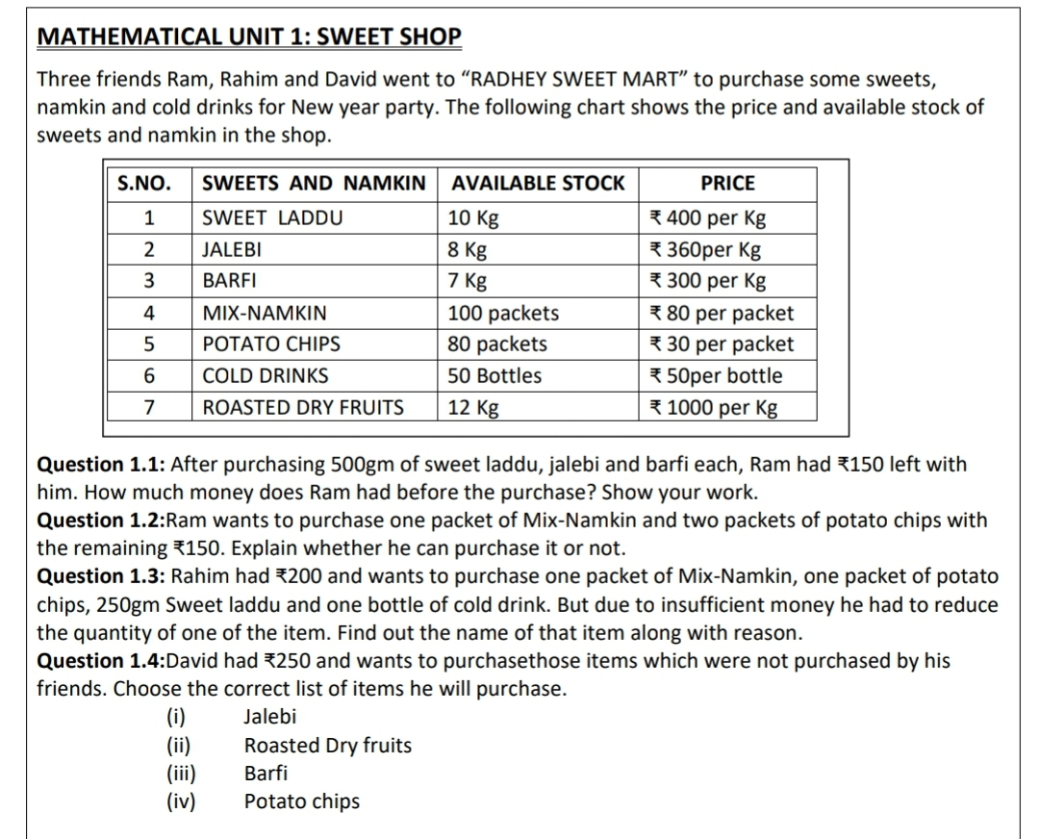
- CCT QUESTION:
CLASS- IX
SUBJECT- MATHEMATICS
INSTRUCTIONS:
- Read all the questions carefully before solving. Write the solution of questions in Mathematics holiday work notebook.
- Complete the project separately on A4 sheets in neat and clear hand writing and attractive.
- Write your name, class and section clearly at the front cover page of project file.

Section A (Questions)
- Let x and y be rational and irrational numbers, respectively. Is x+y necessarily an irrational number? Give an example in support of your answer.

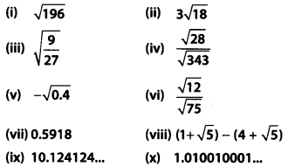
- Classify the following numbers as rational or irrational with justification

- Do as directed
  - Multiply: x³-3x² +5x -3 by x-2.
  - Add : 5x³-x² +7x -3 and 7x³-3x² -32
  - Subtract: x³-3x² -39 from 14x³-3
- Find three rational numbers between
(i) -1 and -2
(ii) 0.1 and 0.11
- Find three irrational numbers between
(i) 5/7 and 6/7
(ii) 1/4 and 1/5
- Locate √5, √9.2 and √7 on the number line.
- Express the following in the form p/q, where p and q are integers and q≠0
(i) 0.2
(ii) 0.888…
(iii) 5.2323...
(iv) 0.001
(v) 0.2555…

- Determine the degree of each of the following polynomials.
(i) 2x – 1
(ii) -10
(iii) x³ – 9x + 3x⁵
(iv) y³(1 – y⁴)
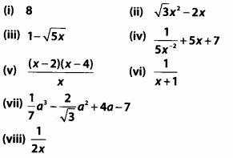

- Which of the following expressions are polynomials? Justify your answer:
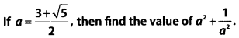

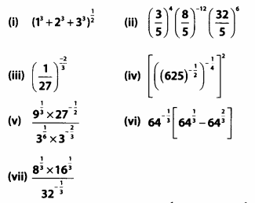
- Simplify

Section B (project work/activities)

- Make a project on the title “π - WORLD'S MOST MYSTERIOUS NUMBER”

- Perform following activities and write in activity
notebook:

- Activity 1: OBJECTIVE : To construct a square-root spiral upto atleast √23”

CCT QUESTIONS
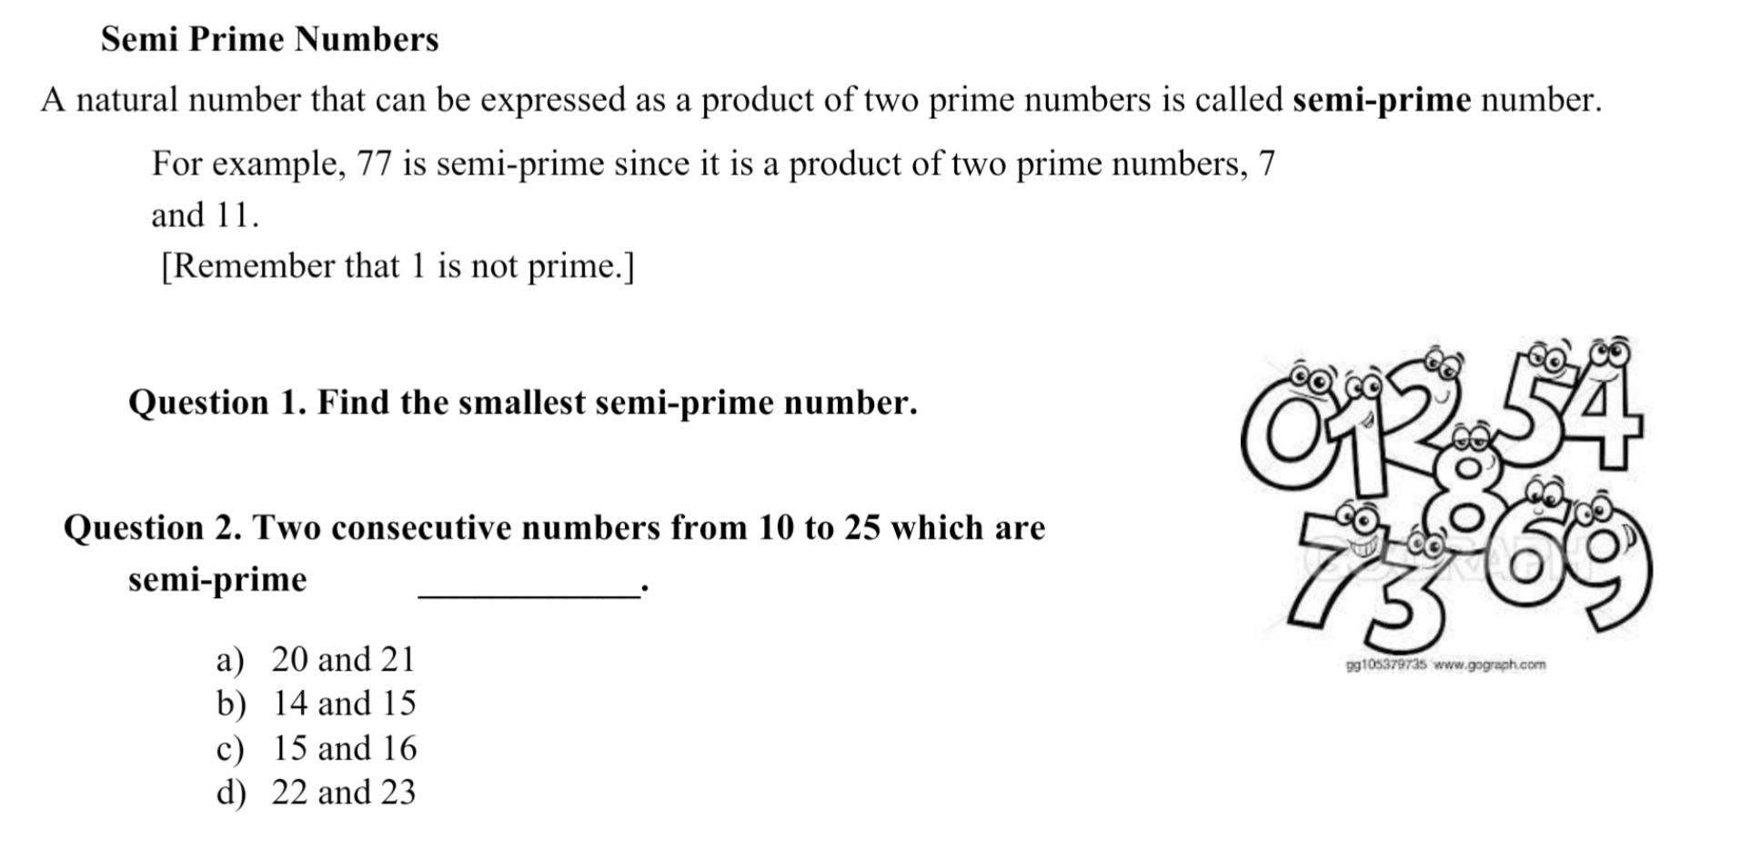

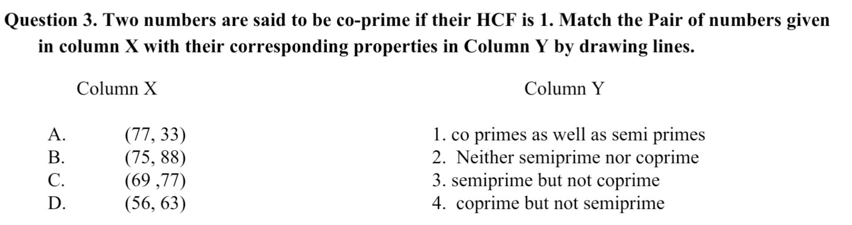

MATHEMATICS
CLASS- X
Section A (Questions)

- Check whether 75/455 is terminating or non-terminating decimal expansion.
- Check whether 654.737373... is a rational number.Justify.
- A polynomial of degree 2 is called -------------------polynomial. (Cubic/ quadratic/ linear)
- √25 is a ----------------number. (rational/irrational)
- Find the p/q form of 0.09999....
- Find the H.C.F. of 567 and 255 using Euclid’s division lemma.
- Find the LCM and HCF of 510 and 92 and check whether LCM x HCF = product of the given numbers .
- Find the degree of :
(i)6x³ -7x -3 (ii) 4x⁴ -3x⁵-4x+1 (iii)

- If p(x)= x³-3x² +5x -3 . find p(2), p(-1).
- Prove that -√3 is an irrational number.
- Prove that 2 -7√3 is an irrational number.
- Factorize the following polynomials:
- 4x² – 3x – 1
- 3x² + 4x – 4
- 5t² + 12t+ 7

- Prepare a table representing different solids and their names, surface areas and Volumes formulas.

Section B (project work/activities)

- Make a project on the title “ π - WORLD'S MOST
MYSTERIOUS NUMBER”

- Perform following activities and write in activity
notebook:

Activity 1: OBJECTIVE : To give a suggestive demonstration of the formula that the area of circle is half the product of its circumference and radius.
Activity 2: OBJECTIVE : To Derive the formula for Volume of a cube and cuboid using model and verify with example and calculation.

- CCT QUESTIONS

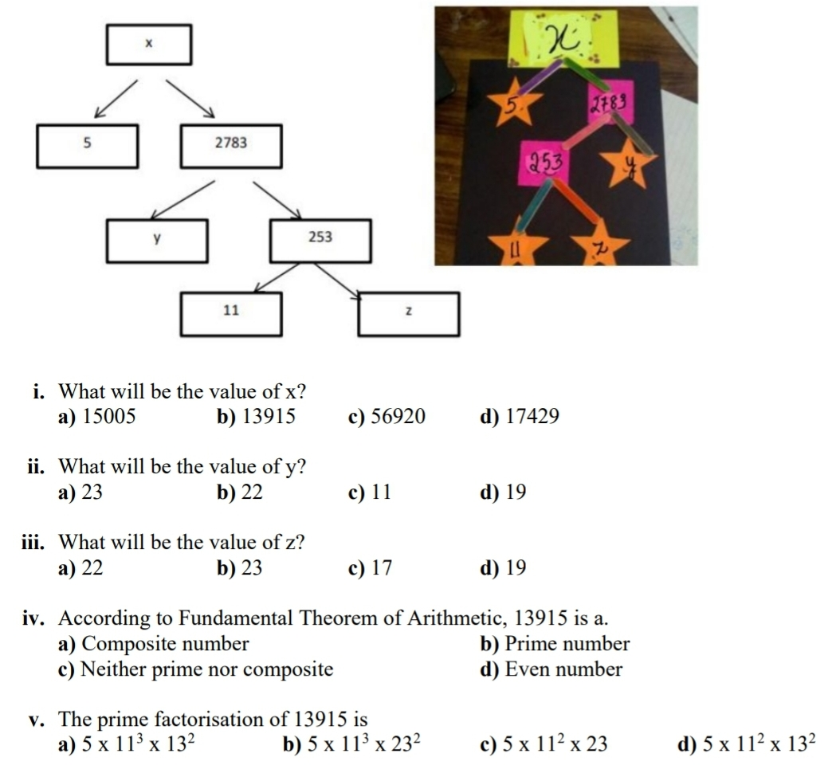
(i) A mathematical Exhibition is being conducted in your school and one of your friends is making a model of a factor tree. He has some difficulty and ask for your help in completing a quiz for the audience. Observe the following factor tree and answer the following.

(ii)
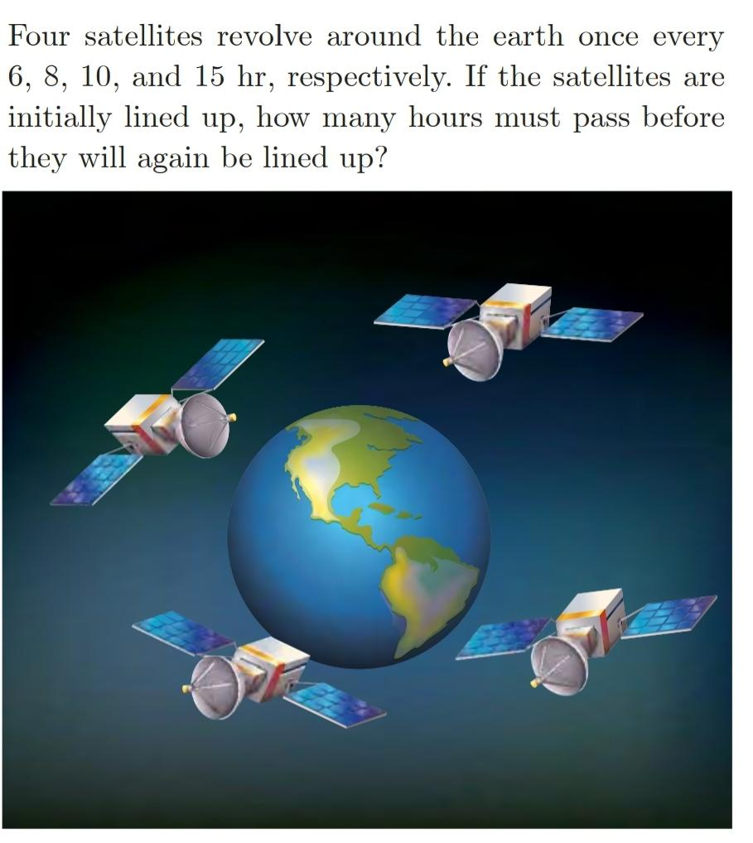

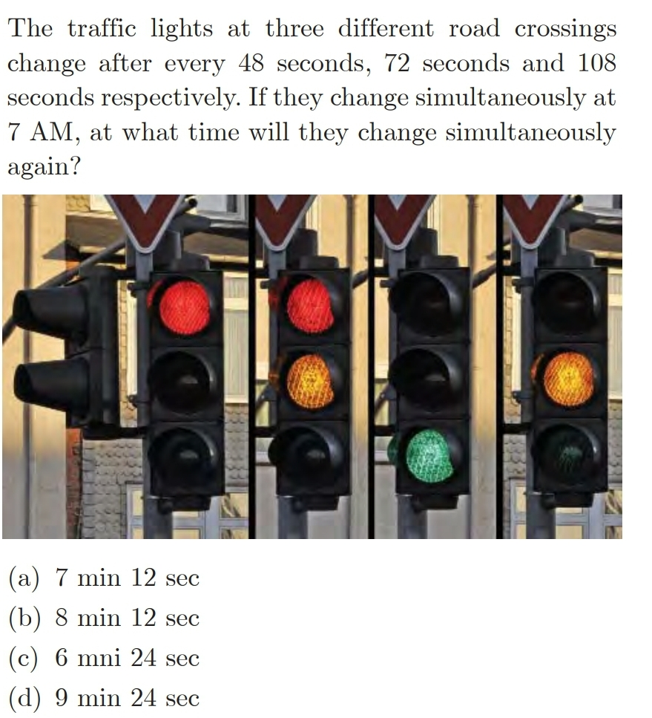
(iii)

(iv)
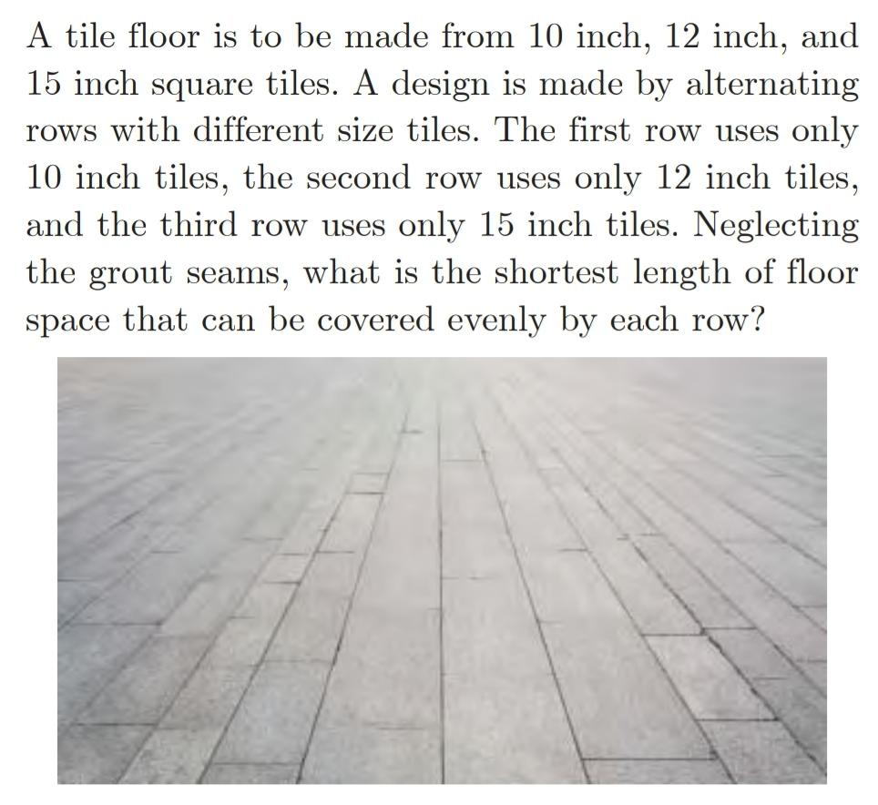

CLASS – 6
Subject- English

1. Write a notice to put up on school notice board as you have found a Red colour Milton Tiffin box outside your classroom. Consider yourself as the headhoy of class 6.
2. Write an application to your school Principal as you are not well and want to take two days leave . Suppose yourself as Sanu.
3. Make a project, showing your house and home with your family members and give description of the house and home .
4. Watch/ read English news daily then write 5 nouns , adjective from the news.
5. Learn the lesson Who did Patrick’s homework and A tale of two birds .

CLASS – 7
Subject- English

1.Write a notice to put up on school notice board as you have lost your Milton Red Water bottle in the school ground after lunch . Consider yourself Nima as the headgirlof class 7
2. Write an application to your school Principal as you want to attend your younger sister's birthday hence you need one day leave . Suppose yourself as Sanu.

3. Learn Lesson The three questions and The tiny teachers from your text .
4. Watch / Read English newspaper or news daily and identify and write 5 nouns, Adjectives and verb forms daily .

CLASS – 8
Subject- English

1. You and Shyam, Admission In Charge of SS Convent School, Mathura. Draft a notice of registration for Admission to classes 1 to 9 for the school.
2.Write a letter to your friend inviting him on your coming Birthday on next Friday .You are Anish , a student of class 8 ,living in Jawahar Nagar Jaipur .
3.Learn Lesson The best Christmas present in the World and The Ant and the cricket, How the camel got his hump from your textbook.
4. Watch / Read English newspaper or news daily and identify and write 5 nouns, Adjectives and verb forms daily
CLASS – 9
Subject- English

1. Learn Lesson The fun they had and The road not taken from your textbook.
2. Make a project for Tense ,showing all the 12 types of Sub Tenses with examples and H.V., M.V..
3. Watch / Read English news or newspaper daily and identify and write 5 nouns, Adjectives and verb forms daily .
4 Write a letter to Your friend informing him for the plan during Summer Vacation for going on a trip .Consider yourself as Naveen, living at 112 Nehru Nagar Jaipur.

CLASS – 10
Sibject- English

1.Learn Lessons A letter to God and Nelson Mandela Long Walk to Freedom from your textbook.
2. Make a project for Tense ,showing all the 12 types of Sub Tenses with examples and H.V., M.V..
3. It was raining heavily, the street lights had gone off and I was returning…………. Complete the story in about 150-200 words, providing an appropriate title to it.
4.Watch / Read English news or newspaper daily and identify and write 5 nouns, Adjectives and verb forms daily .

CLASS – VIII. SUB. – SCIENCE
- Collect the pictures of various agricultural implements and Paste then into your notebook. Write down their usage.
- Write the application of manure and fertilizers in crop production .
- Collect information about the various methods of irrigation followed. Categorise them into conventional and modern methods. Which method you like the most and why?
- A) Visit the garden and collect the leaves with white patches. Paste the picture in your notebook.
B) Write a comparison between the normal leaves and leaves With white patches.
- Under the guidance of your mother or an elder at home make Arrangement for the formation of curd. Write your experience In the form of a paragraph. Also write the name of bacteria
Involved in formation of curd.
- Explain the different way by which farmer can increase soil fertility.
- How are microorganism helpful to us.
- Explain the communicable disease with help of example.
- Write the short paragraph on following –
  - Vaccine. B. Antibiotic
- List the various preservatives and methods of their Preservation.
- List down the food items that are generally spoiled by the Presence of bacteria. Taking any one example explain how It can be prevented.
- Project 1 . Knowing some plant diseases
Objectives
(i) To recognise and observe plants with diseases
(ii) To find out the organisms causing the diseases
Background
Flowers in the garden, crops in the field, vegetables in kitchen Garden, fruits on the trees, etc., are damaged by disease causing organisms. This in many cases leads to loss in production which makes the lives of millions of families in our country miserable. It is thus important to know the organisms that cause the diseases and learn about its control measures.
Methodology
1. Visit a nearby crop field or an orchard or even a garden in the neighbourhood or look at potted plants in your house.
2. Observe the plants which are damaged due to disease. The damage may be the whole or part of a leaf, stem, flower or fruit of a plant. Examine part of the plant carefully, particularly the leaf specially their under surface.
3. Try to find out the name of the disease and the organism causing the disease. Take the help of your elders, farmers or caretaker depending upon the place of your visit. In many cases they may not be able to identify the name of the disease and the disease causing organism. You may then consult an agriculturist/horticulturist for reliable Identification
4. Prepare a table as shown below and write the information that you have collected
- Name of the plant. B. Part damaged Leaf/Stem/Flower, etc.
C. Sign of the disease
D. Name of the organism causing the disease
Conclusion
Write a paragraph about disease causing organisms in plants that you have studied and present it in your class. Describe the diseased or damaged part of the plant. Draw/sketch or illustrate using appropriate means.

- Project 2 Diseases associated with the Human digestive system
Objectives
(i) To know the diseases that are associated with the digestive system in human beings.
(ii) To know about the organisms which cause the diseases.
Background
We suffer from many diseases associated with our digestive system. Such as diarrhoea, dysentery, cholera, typhoid, etc. The organisms causing these diseases are different. These organisms reach our digestive system when we consume contaminated food and water.
Methodology
1. Visit a doctor in your locality to gather information about the diseases related to the digestive system that occur frequently. You can also consult your family doctor or collect information from health centres.
2. Ask for the symptoms of those diseases.
3. Ask the doctor or any reliable sources about the names of the organisms that cause those diseases.
4. Find out how these organisms enter our body.
5. Discuss with either a doctor or consult health centres to know about the measures that we can take to prevent and control such diseases.
Conclusion
Prepare a chart with a table showing the information collected by you.
Follow-up
1 Display the chart prepared by you in your class or on the display board of your school.
2 Survey in your locality/village the number of people who have suffered from diseases related to the digestive system in the last three months.
CLASS – VII. SUB. – SCIENCE
- Make structure of stomata by using kidney beans. How does the stomata contribute in photosynthesis and transpiration.
- Divide the human digestive system into various stages. Draw a flowchart depicting various stages of human Digestive system along with the organs involved in digestion.
- Take different coloured papers. Cut them into various shapes resembling with that of the human digestive organs such that one colour represents one organ. Paste them into your copy making the complete human digestive system. Label various organs.
- Fast food is not good for health. Compose a story with the Above message wherein a girl explains to her younger Brother, the bad effects of eating fast food.
- Do the given questions –
  - How leguminous plants help in nitrogen fixation.
  - What are villi? What is their function and location?
  - Name the carbohydrate that can be digested by ruminant but not by humans? Give reason also.
  - Can we survive on grass? Give reason.
- Write any four healthy food habits which we must follow? Draw/ paste picture related to their habits.
- What are different more of nutrition. Explain by making the flow chart.
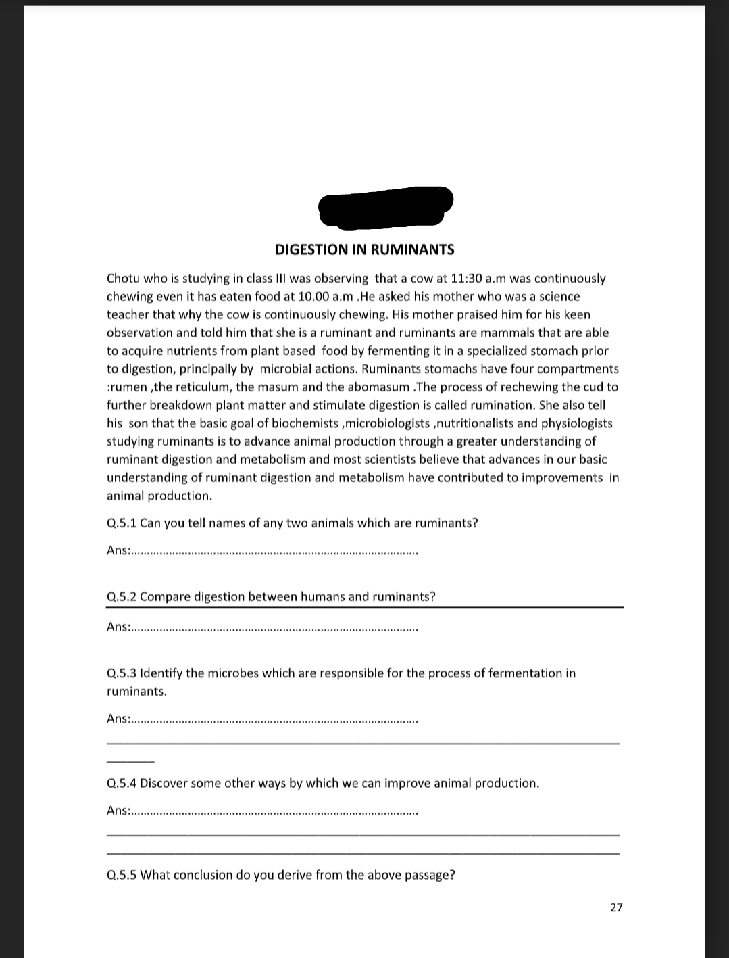
- Why our body can’t make food from carbon dioxide and water like plants.
CASE STUDY BASED QUESTIONS –

Topic : PLANT WHICH HUNT
Some plants cannot prepare their own food as they do not have chlorophyll.
We generally see a yellow wiry branched structure twinning around the stem and branches of a tree figure ‘a’. This is a plant called cuscuta. It does not have chlorophyll; it takes readymade food from the plant on which it is climbing. The plant on which it climbs is called the host and it itself is called parasite.
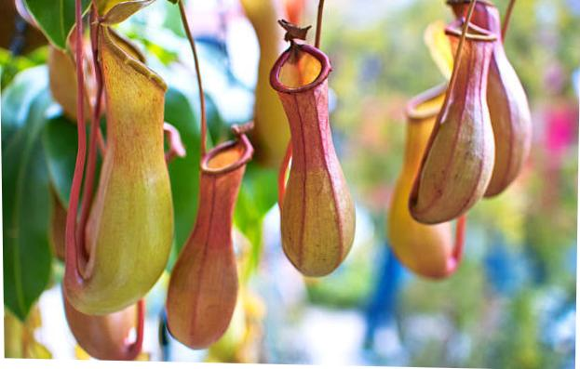
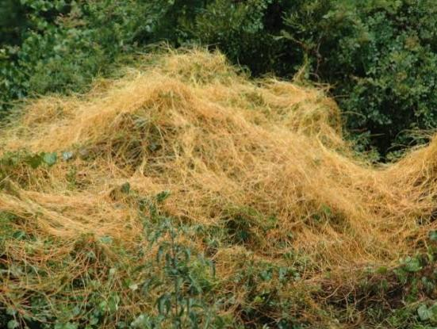

In the figure ‘b’, you can see the amazing structure on plants. These are actually modified leaves having pitcher-like or jug-like shape. The apex of the leaf forms a lid like structure that can open or close the mouth of the pitcher. Inside the pitcher there are hair which entangle the trapped insect. The insect is killed by the juices secreted in the pitcher and the nutrients are absorbed. Such insect eating plants are called insectivorous plants. Such plants are found in Australia, Indonesia and Meghalaya in India.
.
Q 5.1: Pitcher-like structure is:
- Modified stem
- Modified branch
- Modified leaf
- Modified bud
Q 5.2: If the pitcher plant is green and carries out photosynthesis, then why they are called as carnivores plants?
Q 5.3: These plants have a special smell that:
- Attracts insects.
- Keep the environment pleasant.
- Attracts the tourists.
- Provides it pitcher-like shape.
Q 5.4The plant shown in figure ‘a’ is non green and does not have even the expanded leaves. Then how could it survive on the plant on which it is growing ?
Q 5.5 In India where can you find cuscuta and insectivore plants?
CLASS – VI. SUB. – SCIENCE
- To find out the nutrients present in different packed food (health drinks)
- Collect 5 packed items that are available in market.
- Make a list of nutrients found in them.
- Find out the amount of each of the nutrients present in them.
- Note down your observations.
- From your observations, which food items are good or not good for your health.

- Write names of nutrients present in different fruits and vegetables
  - Paste the pictures of different sources of nutrients in your Notebook.
  - Also mention the importance of each nutrient
- Now plan the diet chart for
a) Growing children b) Old grandparent
4. A blood test report shows that your friend is suffering from Anaemia. Suggest ways/change in. Eating Habits to Your friend for her Early recovery.
5. List out the food items obtained from plants and animals ( 5 each type). Paste the pictures in your notebook.
6. Write the name of ingredients used for making below food items –
a. Sambhar. B. Pander butter masala
C. Biriyani. D. Aloo Paratha
7. Name the following:
(a) The nutrients which mainly give energy to our body.
(b) The nutrients that are needed for the growth and maintenance of our body.
(c) A vitamin required for maintaining good eyesight.
(d) A mineral that is required for keeping our bones health
CLASS – IX. SUB. – SCIENCE
- Make a list of evaporation phenomena activities which happen in our surroundings to understand evaporation liquid2.
- Write boiling point of any five liquids .
- a. Draw a plant cell and name seven important organelles found in it.
B. Name one organelle that can make some of its own protein in a plant cell and also. mention one Function of such an organelle.
C. Where are chromosomes located.
4. Draw a neat diagram of an animal cell and label the following organelles:
- Plasma membrane b. Golgi apparatus
- Centriole d. Rough endoplasmic reticulum
5.Pressure on the surface of a gas is increased. What will happen to the inter particle forces?
6. Name the three states of matter.
7.What happens when a liquid is heated ?
8. Convert the following temperature to Kelvin Scale (a) 100°C(b) -100 C
9.What is meant by density?
10. Give the characteristics of the particles of matter.
11. Water droplets seen on the outer surface of a glass containing ice-cold water is due to
_____________ .
12.Change of gaseous state directly to solid state without going through liquid sate is called
___________________ .
13._________________ is a surface phenomenon.
14.Explain why temperature remain constant during the change of state of any substance?
15. Do we sweat more on a dry day or humid day ? Justify your reason.
16.Why do we see water droplets on the outer surface of a glass containing ice cold water?
17. Convert the following temperature to the CELCIUS scale (a) 25K (b) 373K
18.List two properties that liquids have in common with solids.
19. List two properties that liquids have in common with gases.
20.What will happen to the melting point of ice if some common salt is added to it? Justify your observation.
21.How will you show that air has maximum compressibility?
22. Define the term (a) Latent heat of fusion (b) Latent heat of vaporization
23. Prepare a project report on various sample of –
a) A mixture. B) a compound. C) an element ( metal and non metal) d) highlight the main characteristic feature of element compound and mixture.
24. Prepare a report on 4th and 5th state of matter.
CLASS -X SUBJECT – SCIENCE
Q1. Write symbols of elements and their name in given your textbook (ch. 1 and learn them )
Q2. Write the name of compounds and their name in given your test book .
(ch.1)
Q3. What is a balanced chemical equation? Why should chemical equations be balanced?
Q4.Write the balanced equation for the following chemical reactions.
- Hydrogen + Chlorine → Hydrogen chloride
- (ii) Barium chloride + Aluminium sulphate → Barium sulphate + Aluminium chloride
- (iii) Sodium + Water → Sodium hydroxide + Hydrogen
Q5. Write a balanced chemical equation with state symbols for the following reactions.
- Solutions of barium chloride and sodium sulphate in water react to give insoluble barium sulphate and the solution of sodium chloride.
- Sodium hydroxide solution (in water) reacts with hydrochloric acid solution (in water) to produce sodium chloride solution and water.
Q6. Why are decomposition reactions called the opposite of combination reactions? Write equations for these reactions.
Q7.What is the difference between displacement and double displacement reactions? Write equations for these reactions.
Q.8. Write the balanced chemical equations for the following reactions and identify the type of reaction in each case.
- Nitrogen gas is treated with hydrogen gas in the presence of a catalyst at 773K to form ammonia gas.
- Sodium hydroxide solution is treated with acetic acid to form sodium acetate and water.

Q9. Complete the missing components/variables given as x and y in the
following reactions

- Pb(NO₃ )₂ (aq) + 2KI(aq) → PbI₂ (x) + 2KNO₃ (y)
- Cu(s) + 2Ag NO₃ (aq) → Cu(NO3 ) ₂ (aq) + x(s)
- Zn(s) + H₂ SO4 (aq) → ZnSO4 (x) + H₂ (y)
- CaCO₃ (s)→x CaO(s) + CO₂ (g)
Q10.Which among the following are physical or chemical changes?

- Evaporation of petrol

- Burning of Liquefied Petroleum Gas (LPG)

- Heating of an iron rod to red hot.

- Curdling of milk

- Sublimation of solid ammonium chloride

Q11.Distinguish between food chain and food web.
Q12. What do you mean by biological magnification m

Q13. Explain how ozone layer is formed. Explain the reason of ozone layer depletion and its consequences on human and animal life.

Case study questions
Q22. Read the following and answer any four questions from (i) to (v). A reaction in which two or more reactants combine to form a single product is called a combination reaction. For example, calcium oxide reacts vigorously with water to form calcium hydroxide. The reaction is highly exothermic in nature, as lots of heat is produced during the reaction.
CaO(s)+H₂O(l)Ca(OH)₂(aq)+ Heat CaO(s)+H₂O(l)Ca(OH)₂(aq)+ Heat
Calcium oxide Water Calcium hydroxide

Solution of Ca(OH)₂ is used for white wash the walls. Calcium hydroxide reacts slowly with carbon dioxide in air to form a thin layer of calcium carbonate on the wall which gives a shiny appearance to wall. Calcium carbonate will form after two or three days of white wash.
- What is the chemical name of quick lime?
(d) Carbon
  - Calcium (b) Calcium (c) Calcium dioxide
oxide carbonate hydroxide

- When carbon dioxide is passed through lime water,
  - calcium hydroxide is (b) white precipitate of CaO is formed
(c) lime water turns milky
(d) colour of lime water becomes

- Following observations are observed when calcium oxide reacts vigorously with water.
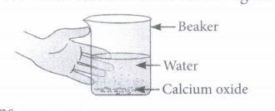
Identify the incorrect observations
(I) It is an endothermic reaction (II) Slaked lime is produced.
(III) Quick lime is produced. (IV) It is an exothermic reaction. (V) It is a combination reaction
  - (I) and (II) (b) (III) and (IV) (c) (I) and (III) (d) (II), (IV) and (V)
- Quick lime combines Vigorously with water to form (A) which reacts slowly with the carbon dioxide in air to form (B)
Identify the compounds(A) and (B)

(A) | (B)
(a) Calcium carbonate | Calcium hydroxide
(b) Calcium hydroxide | Calcium carbonate
(c) Calcium | Calcium bicarbonate
(d) Calcium bicarbonate | Calcium
- Among the following, the endothermic reaction is
  - combination of carbon and oxygen to form carbon monoxide
  - combination of nitrogen and oxygen to form nitrogen monoxide
  - combination of glucose and oxygen to form carbon dioxide and water (d) combination of zinc and hydrochloric acid to form zinc chloride and hydrogen

Q25. Reactions in which one element takes place of another element in a compound, are known as displacement reactions. In general, more reactive elements displaces a less reactive element from its compound. In all single displacement reactions, only one element displaces another element from its compound. The single displacement reactions are, however, written as just displacement
reactions. The displacement reaction between iron (III) oxide and powdered aluminium produces so much heat that iron metal obtained is in molten form.
- Copper displaces which of the following metals from its salt solution?
  - ZnSO₄ (b) FeSO₄ (c) AgNO₃ (d) NiSO₄
- When zinc reacts with dilute sulphuric acid, the gas evolved is
  - red in colour and have a sweet smelling
  - green in colour and have a foul smell
  - colourless, odourless and burns with a pop sound
  - colourless, pungent smelling and burns with a pop sound
- When dry hydrogen is passed over a heated oxide of metal X using the apparatus shown below, a reddish-brown residue is obtained
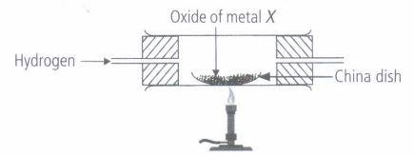
The reddish -brown residue could be
  - copper (b) lead (c) silver (d) zinc
- Which of the following reactions is a displacement reaction?
  - CaO+H2OCa(OH)2 (a) CaO+H2OCa( (b) MgCO3Mg+CO2 (b) MgCO3
OH)2 Mg+CO2
(c) Mg+CuSO4MgSO4+Cu (c) Mg+CuSO4 (d) H2+Cl22HCl (d) H2+Cl22
MgSO4+Cu HCl
- When dilute hydrochloric acid is added to granulated zinc placed in a test tube, the observation made is
  - the surface of the metal turns shining
  - the reaction mixture turns milky
  - greenish yellow gas is evolved
  - the colourless and odourless gas evolves with a pop sound.

विषयः संस्कृतम् कक्षा: षष्ठी ( 6 )

* अकारान्त पुँल्लिङ्ग शब्द एकवचन द्विवचन बहुवचन रूपाणि ( पुँल्लिङ्गः )
Example : बालकः बालकौ बालकाः ( Write 15 Words like this )
* आकारान्त स्त्रीलिङ्ग शब्दाःएकवचन द्विवचन बहुवचन रूपाणि ( स्त्रीलिङ्गः )
Example : लता लते लताः ( Write 15 words like this )
* संस्कृत वाक्यानि ( 25 ) लिखत ।
Example 1) बालकः पठति । 2)गजः चलति । 25 Sentences like this
* बालकः , बालिका , पुष्पम् शब्दरूपाणि लिखत । Page No. 89 & 90
* पठ् , गम् धातुरूपाणि लिखत । ( लट् - लृट् - लङ् ) page No. 92 , 93 & 94
* संस्कृत छात्र-प्रतिज्ञां लिखत ।
विषयः संस्कृतम् कक्षा: अष्टमी ( 8 )
* सुभाषितिनि श्लोकान् लिखत । Write सुभाषितानि Poems .
* संख्याः 1 - 60 संस्कृते लिखत । Write 1-60 numbers in Sanskrit.
* बालक , बालिका , नदी , पुष्पम् शब्दरूपाणि लिखत ।
* किम् शब्दः ( पुँल्लिङ्ग-स्त्रीलिङ्ग-नपुंसकलिङ्गाः )
* धातुरूपाणि ( पठ् , खाद् , क्रीड् , लिख् ) लट्-लृट्-लङ् ( वर्तमान- भविष्यत्-
भूतकालाः)
* संस्कृत प्रतिज्ञां प्रार्थना च लिखित्वा अभ्यासं कुरुत ।
केन्द्रीय विद्यालयः सी सु बल रामगढ़
ग्रीष्मकालीन आवकाशिक गृहकार्यम्
विषयः संस्कृतम् कक्षा: सप्तमी ( 7 )
* सुभाषितानि श्लोकान् लिखत , कण्ठस्थीकुरुत । Write सुभाषितानि Poems and
Learn
* संख्याः 1 - 50 संस्कृते लिखत । Write 1-50 numbers in Sanskrit
Write some Examples with pictures.
* किम् शब्दः ( पुँल्लिङ्ग-स्त्रीलिङ्ग-नपुंसकलिङ्गाः )
* धातुरूपाणि ( पठ् , खाद् , क्रीड् ) लट्-लृट्-लङ् ( वर्तमान- भविष्यत्-भूतकालाः)
* संस्कृत प्रतिज्ञां प्रार्थना च लिखित्वा कण्ठस्थीकुरुत ।
CLASS: VI
SUMMER VACATION HOME WORK
SUB : SOCIAL STUDIES

- Collect more facts about the Earth and the Moon.
(Also illustrate with pictures/drawings)
- Make a list of differences and similarities between any two Indian states.
- “India has unity in diversity” prove in your explanation (about 200 words)
- What were the subjects on which books were written in the past? Which of these books would you like to read?
- Write an article on “Rain water harvesting”
- MAP-POINTING
- On an outline map of the world label or point the following
- Continents and Oceans (map1)
- Mountains and Rivers (map2)

All The Best
CLASS : VII
SUB : SOCIAL STUDIES

* DRAW THE DIAGRAM OF ROCK CYCLE.
* NOTE DOWN THE ROCKS AND MINERALS AVAILABLE IN YOUR DISTRICT.
* WRITE THE CHRONOLOGY OF MEDIEVAL INDIA.
* STUDY THE PROBLEMS FACED BY OMPRAKASH VALMIKI AND ANSARI IN THEIR LIVES.
* MAP POINTINING – IDENTIFY DIFFERENT STATES AND UNION TERRITORIES AND WRITE THEIR CAPITALS ON INDIA MAP.
All The Best
CLASS: VIII
SUB : SOCIAL STUDIES

- WRITE AN ARTICLE ON ANY TWO OF THE FOLLOWING
- Water Scarcity and Conservation of water resources
- Resource Conservation
- Human Resource
- Write a note on the following
- Importance of Fundamental Rights in a democracy
- Indian Secularism
- Collect news articles from Newspapers regarding ‘issues of government and individuals’
- Collect pictures, stories, poems and information about any two of the following
- The Rani of Jhansi
- Mahadji Sindhia
- Haidar Ali or Tippu Sultan
- Maharaja Ranjith Singh
- Lord Dalhousie

- MAP-POINTING
- On an outline map of India label the following
  - 19th Century Trade Centers
  - Sea ports
- Make a list of a few countries Capitals, Currencies and Languages (at least 20 countries)

CLASS—IX
SUB : SOCIAL STUDIES

- Write short note on any 4 topics given below (about 100 words each)
- Indian Standard Meridian
- India and it’s neighbors
- Union Territories
- Largest countries of the world according to area and population
- 5 largest and 5 smallest states according to area and population
- Write an article on United Nation (about 350 words)
- Write an essay on a revolution which inspired European countries for democracy (about 250 words)
- MAP-POINTING
- Indian Union Territories, its capitals, Governors and Chief Ministers
- Countries, Capitals and currencies
- Germany
- France
- Russia
- Poland
- Myanmar
- Nepal
- Chile
- Ghana
- Afghanistan
- Bangladesh
CLASS-X
SUB : SOCIAL STUDIES
- Maharashtra and Bundelkhand regions of Uttar Pradesh and Madhya Pradesh are facing water scarcity. Collect articles and pictures about given disaster and prepare a report. Give your ideas about water conservation.
- Write an essay on Globalization and it’s impact on today’s world and Indian economy. (about 250 w)
- Write short note on any three points given below- (about 100w)
(i) India Pakistan relations from 1999 to 2016.
(ii) Satyagraha and Mahatma Gandhi
(iii) United Nations Security Council
(iv) Alluvial soil
- Map Pointing-
- On India Political map-
Write capital, chief minister governor, soil and main crops names of given states-
Gujrat, Maharashtra, Uttar Pradesh, Andhra Pradesh/Telangana, Kerala
- On World political map-
Write capital, head of governments either president or prime minister, language and currency-
France, England, United states of America, Belgium, Sri Lanka, Bangladesh, Pakistan, Afghanistan, Maldives, Nepal.

