KENDRIYA VIDYALAYA BSF RAMGARH
WINTER BREAK HOMEWORK
CLASS – I MATHS
- WRITE NUMBER NAMES FROM ONE TO FIFTY.
- WRITE COUNTING FROM 1TO 50.
- WRITE REVERSE COUNTING FROM 50 TO 1.
- WRITE AND LEARN TABLE OF 2 AND 3.
- MAKE 5 GROUPS OF MATCHSTICKS, EACH GROUP CONTAINS 10 STICKS.
NOTE – DO IT IN MATHS NOTEBOOK
कक्षा – 1 (हिन्दी)
1. हिन्दी वर्णमाला (अ से ज्ञ तक ) पांच बार लिखो |
2. क से ज्ञ तक पांच बार बारहखड़ी लिखो |
3. आ , इ , ई , उ , ऊ ,ए , ऐ , ओ तथा औ की मात्रा वाले दस –दस शब्द लिखो |
4. गर्मियों व सर्दियों में मिलने वाले कोई भी दो फलों के चित्र एक A-4 साइज़ शीट पर बनाए और उसमे रंग भरें |
5. पतंग और पकौड़ी कविता उचित हाव भाव के साथ याद कीजिए |
Class-1 sub- EVS

Learn and write name of wild and domestic animals (5 each)
Learn the name of vegetables and fruits (10 each)
Learn and write 5 lines about the following topic.
Animals
Class- I Sub.- English
Reading- one page each day.
Q.1 Write opposite words (any five).
Q.2 Write rhyming words (any five).
Q.3 Draw a picture of parrot and colour it.
Q.4 Write name of birds (any five).
Q. 5 Write name of flowers. (any five).
Q.6 Write name of your grandparents
(dada, dadi, nana, nani).
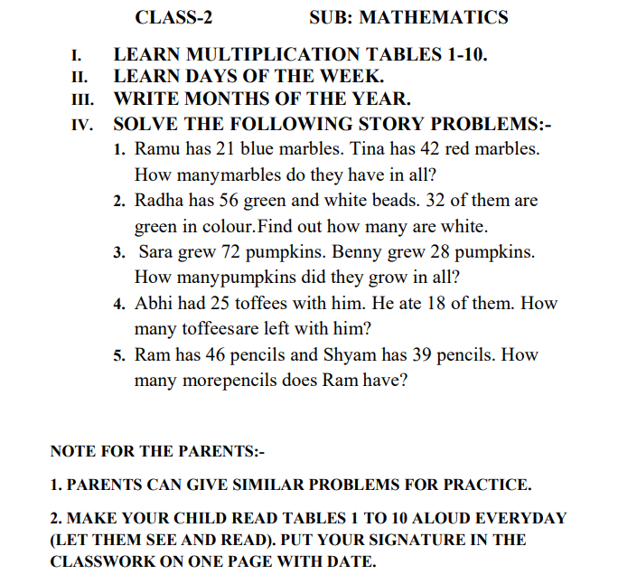
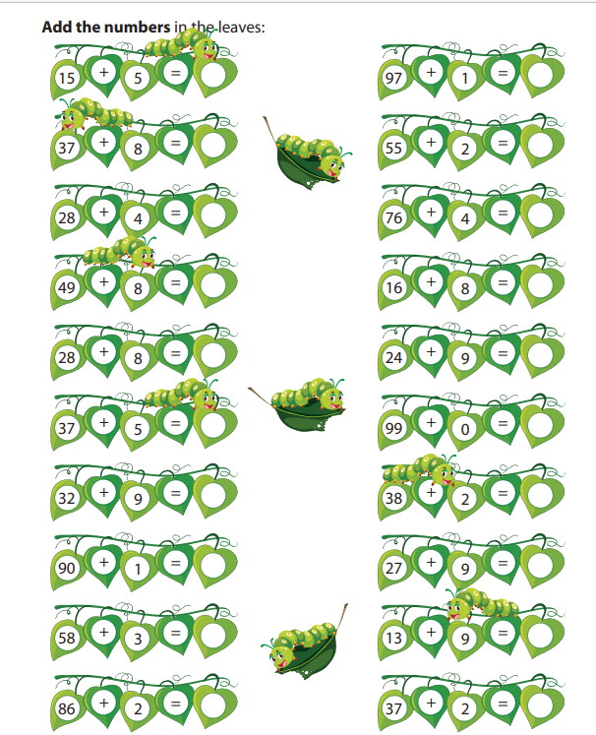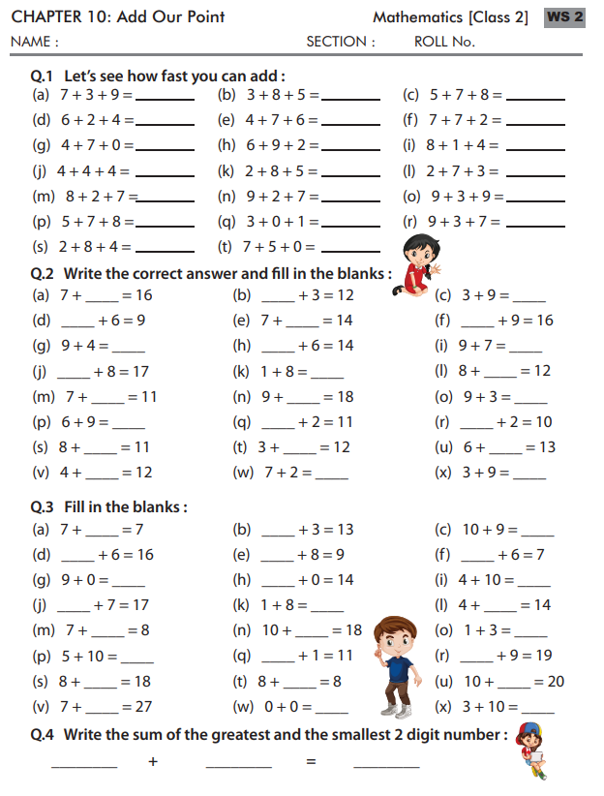

CLASS – II ENGLISH
WRITE 10 TIMES CURSIVE ALPHABET.
READ ONE PAGE FROM TEXTBOOK DAILY.
MAKE A GREETING CARD FOR NEW YEAR
LEARN QUESTION AND ANSWERS OF UNIT-8.
LEARN ANY 3 POEMS.
NOTE – DO IT IN ENGLISH NOTEBOOK.
CLASS-II [EVS]
1. Draw the pictures of Sun ,Moon and Stars . Write two sentences about them .
2. Collect leaves of different plants from your locality and paste them in your note book.
3.Draw a plant and label its parts .
4.Collect feathers of some birds and paste them in your note book.
5. Draw some trees and write in one sentence how trees help to keep the air fresh
6. Revise chapters :- 1) Means of transport 2) Seasons
कक्षा -2 विषय – हिंदी
1. 5 पेज़ अपनी किताब में से सुंदर- सुंदर लिखावट में लिखना ।
2. पाठ (बुलबुल से सूरज जल्दी आना तक) के प्रश्न उत्तर याद करना।
3. तीन वर्ण वाले कोई 20 शब्दों को अपनी पाठ्य पुस्तक में से लिखना।
4. 5 विलोम शब्द व 5 एकवचन से बहुवचन लिखना।

CLASS – 3 EVS
MAKE A SCRAP BOOK – TOPIC : I LOVE MY COUNTRY
PAGE 1 – PASTE MAP OF OUR COUNTRY
PAGE 2 – WRITE NAME OF OUR PRESIDENT, PRIME MINISTER, HOME MINISTER FINANCE MINISTER, DEFENCE MINISTER AND EDUCATION MINISTER WITH PHOTO
PAGE 3- PASTE PICTURES OF OUR NATIONAL SYMBOLS : FLAG, NATIONAL EMBLEM, NATIONAL BIRD, FRUIT, TREE,GAME,FLOWER, ANIMAL AND BIRD.
PAGE 4 – NAME OF STATES AND UNION TERRITORIES WITH CAPITAL.
PAGE 5- INDIAN MAP SHOWING ALL STATES AND U.T.
PAGE-6 INDIAN MAP SHOWING ALL MOUNTAIN RANGES.
PAGE- 7 INDIAN MAP SHOWING MAIN RIVERS.
PAGE- 8 INDIAN MAP SHOWING DESERT.
PAGE- 9 INDIAN MAP SHOWING NEIGHBOURING COUNTRIES.
WRITE AN ESSAY ON “ SAVE NATURE” (DO IT IN A4 SHEET)

कक्षा – 3 हिन्दी
फाइल – मेरा राज्य
पृष्ठ -1 राज्य का नक्शा , राजधानी को प्रदर्शित करते हुए
पृष्ठ -2 मुख्यमंत्री का नाम (तस्वीर के साथ )
पृष्ठ -3 राज्य पोशाक ( सचित्र )
पृष्ठ-4 विशेष भोजन (सचित्र )
पृष्ठ -5 राज्य वृक्ष,पशु, फल, फूल, पक्षी (सचित्र )
पृष्ठ -6 मुख्य त्योहार (सचित्र)
पृष्ठ -7 भाषा का नाम
मुख्य नृत्य
पृष्ठ -8 प्रसिद्ध व्यक्तित्व (सचित्र विवरण )
पृष्ठ -9 प्रसिद्ध स्मारक (सचित्र )
नोट – उपरोक्त सभी कार्य A 4 शीट पर करें एवं उन्हें फाइल में व्यवस्थित तौर पर लगाएँ |
‘प्रकृति बचाओ ‘ पर लेख लिखें | (A4 SHEET)

Class – III Sub.- English
- Collect leaves of three different plants and paste on a paper and write some sentences on each leaf (MDP).
- Do five pages handwriting.
- Do reading (one page each day).
- Write and learn new words of Unit – 6, 7, and 8.
Class- 3 sub- maths

Writing and memorising tables from 1 to 10.
Solving the ten divisions problem of two digits.
Exp - 25/5= 5
Solving the ten multiplication problem of two digits.
Exp - 22X12=264
Solving the ten subtraction problem of three digits.
Exp -222-111= 111
Solving the ten addition problems of three digits.
Exp -101+201=302

CLASS-IV
➢ MATHEMATICS
1. Draw any 5 shapes. Divide them into two equal parts and colour any one part of
them.
2. Draw any 5 shapes. Divide them into four equal parts and colour any one part
of them.
3. Draw four circles having radius 4cm, 5cm, 6cm and 6.5cm respectively.
4. Make your own 4 patterns by using this figure.
5. Make 2 magic square boxes.
6. Write 5 secret message by using english alphabet.
7. Write 4-4 things that are measured in litre, meter and kilogram.
➢ ENVIRONMETAL STUDIES
1. Visit to any nearby park/garden and write ten lines about its beauty.
2. Make a poster on save trees.
3. On what occasions do you eat together with your friends or relatives? Who
cooked and served the food there?
4. Help your mother in cooking and serving food at home.
5. Make a chart on various types of beaks of birds.
6. Observe a bird's nest in your surroundings and click a picture of the nest and
try to find out that the nest belongs to which bird?
Class -4 MDP
Subject-maths
1. Write measurement units of maths .
2. Make five photos of measurement tools.
3.Make a table of vegetable rate .( Show with photos)
4 . Make a table of your family uses of water per day .
5. Make a table of different electric items with photo.
Class -4 MDP
EVS
- SOORCE OF WATER
- WRITE STEPS OF RECYCLE WATER
- DESCRIBE THE PROCESS OF RAINWATER HARVESTING WITH HELP OF PICTURE

CLASS-4 ENGLISH

Practice cursive hand writing, one page daily.
Write the name of your favorite book. Write the story neatly (hand writing grades will be given) and underline the describing words from the story with colour pencil or crayon.
Revise all the work done in notebook and book.
Write 10 sentences on Donkey.
Make a puppet using waste materials like cardboard, paper, cloth, thread, sticks, boxes etc.

CLASS-IV हिंदी
1. प्रतिदिन समाचार पत्र पढ़ो व पाँच नए शब्द लिखिए |
2. प्रतिदिन एक सुलेख लिखिए ।
3. आप बड़े होकर क्या बनना चाहते हैं? अपने विचार अभिव्यक्त कीजिये ।
4. अपनी पाठ्यपुस्तक का पाठ 8, 9, 10 और 11 पढ़ें और प्रश्न-उत्तर याद करें।
5. वृक्षों का महत्व विषय पर अनुच्छेद लिखे।
6. 10 विलोम शब्द लिखो।
7. 10 समानार्थी शब्द लिखो ।
MDP Class 4

Class- V Sub. – EVS
- Collect some different types of leaves and paste on a paper and write some sentences on each leaf (MDP).
- Make a collage of tree (MDP).
- Make a poster on ‘SAVE FUEL SAVE FUTURE’
Note- Do your work on A4 size paper.
Revision- lesson- 12 to 16.
कक्षा -5 विषय – हिंदी
1. 5 पेज़ अपनी किताब में से सुंदर- सुंदर लिखावट में लिखना ।
2 पाठ (गुरु और चेला से बिशन की दिलेरी तक) प्रत्येक पाठ में से 5-5 कठिन शब्द लिखना।
3. पाठ (गुरु और चेला से बिशन की दिलेरी तक) प्रत्येक पाठ के प्रश्न उत्तर को याद करना।
4. 10 एकवचन से बहुवचन व 10 विलोम शब्द लिखना।
5. ‘जल संरक्षक’ पर निबन्ध लिखिए
CLASS 5 ENGLISH

Make a colourful folder and keep all the Assignment sheets in it.

Practice cursive hand writing, one page daily.

Write three new words daily and find out their meanings from the dictionary.

3. Write 10 pairs of similar sounding word (Example- two ,too)

4. Revise all the work done in notebook and book.

5. Write any 25 rhyming words and 25 opposite words.

6. WRITE A FEW LINES ABOUT YOUR BEST FRIEND, WHAT
ARE HIS /HER BEST QUALITIES.

Write 20 describing words and make a sentence of each.
MDP
CLASS-5 MATHS
1. Learn and Write Tables from 2-20.
2. Learn and Write the formulae of the following
a. Area of Square b. Perimeter of Square c. Area of Rectangle d. Perimeter of Rectangle
3. Draw a Square of Area 16 cm2
4. Draw Floor map of your classroom.
5. Revise Chapters: Mapping your way, Boxes and Sketches, Tenths & Hundredths

Class 6

1.Write and learn an application to your school Principal , requesting him for 3 days leave as you are Anil , of class 6th is not feeling well for last two days.
2. Write a notice for school notice board as you are Sumer of class 6 th ,head boy of class , one student of your class has lost his student diary one day ago somewhere in school . Announce a reward to the finder when it will be returned to its owner.
3. Make a project on pronoun and give examples with details.
4. Watch or listen English news .
5. Write 10 verbs with present, past or past participle form ,10 synonyms and 10 antonyms from your text book.
6. Learn all the lessons that will come in your PT 2 EXAM.
CLASS – VI – SUB. – SCIENCE
Prepare all the exercise questions from chapter 9 to13.

2. Learn the summary from chapter 9to13.
3. List the common characteristics of the living things.
4. How are cactus adapted to survive in desert.
5. Why could you not use an elastic measuring tape to measure distance? Problems you would meet in telling someone about a distance you have measured with an elastic tape.
6. Write the similarities and differences between the motion of a bicycle and a ceiling fan that has been Switched on.
Q.7. Question no.2 from the exercise questions in chapter 11.
Q.8. Why should an electrician use rubber gloves while repairing an electric switch at your home? Explain.
Q.9. Would the bulb glow after completing the circuit shown in fig. 12.14. If instead of safety pin we use an Eraser?
Q.10. Write any two properties of a magnet?
Q.11. How is compass is used to find directions?
CLASS : VI MATHS
Project :- Prepare a graph for showing increment in yoga practice in last 5 years.
Learn and write tables from 2 to 20 .
Exercise 8.1 Q.N-- any two part of each questions - 2, 3,8
Exercise 8.2 Q.N-- any two part of each questions - 3,4,7
Exercise 8.3 Q.N—1
Exercise 8.4 Q.N—2,5
Exercise 8.5 Q.N – 3,5,7
Exercise 8.6 Q.N – 1,3,6,7
Exercise 9.1 QN - 4,
Exercise 9.2 QN - 1
Exercise 9.3 QN - 2
Exercise 9.4 QN - 2
Exercise 10.1 QN - 5, 11, 13,
Exercise 10.3 QN - 1,4,8
Exercise 11.1 QN- 5,7,8
Exercise 11.3 QN - any two part of each questions 3,4,5
Exercise 11.4 QN - any two part of each questions 1,2,3
Exercise 11.5 QN - 2
Exercise 12.1 QN - 3, 6,8,11,12,15

विषय: - संस्कृतम्
कक्षा छठवी (6th)
1.एकत: दश पर्यन्तं त्रिषुलिंगेषु संस्कृत संख्या लिखत -
( एक से लेकर दस तक की संस्कृत संख्या तीनों लिंगो में लिखिए ) ( पृष्ठ -70-71)
2.इकारान्त पुँल्लिङ्ग मुनि शब्दस्य शब्दरूपाणि लिखत-
(इकारान्त पुँल्लिङ्ग शब्द “मुनि” के शब्द रूप लिखिए ( पृष्ठ -91)
3. चिन्त् (सोचना) धातो: धातुरूपाणि चतुर्लकारेषु लिखत-
चिन्त् (सोचना) धातु के चारों लकारों मे धातु रूप लिखिए) ( पृष्ठ -97-98)
4.स्व परिवारविषये दश संस्कृत सरलवाक्यानि लिखत -
(अपने परिवार के बारे में दश सरल संस्कृत वाक्य लिखिए )

कक्षा 6 विषय हिन्दी
1 बाल रामायण कथा अपने शब्दों मे लिखो -( 150 शब्द)
2 हेलन केलर का जीवन चरित लिखो ।
3 तुम्हारी पसंद की किताब कौनसी है लिखिये।
4 आपकी माँ आपके लिए क्या क्या काम करती हाई लिखिये।
5 हमारा पर्यावरण ' विषय पर निबंध लिखिये ।

Class 7

1. Write an application to your Principal for 2 days leave as you have an urgent work at home. You are Neha .
2. Write 10 verbs with three forms and learn them .
3. Learn all the lessons that will come in PT 2 .
4. Watch and listen English news daily.

Class-vii SUB. – SCIENCE
Prepare all the questions of exercises of all the chapters from chapter no. 11-15.
2. Learn summary of all the chapters from chapter no. 11-15.
3. Draw labelled diagrams of:-
A. Human heart b) Human excretory system
© Pollination in flower. (d) Reproductive parts of a plant
4. Describe the functions of the heart .
5. Draw pictures and symbols for electric circuit components.
6.Draw an electric circuit diagram.
7. Why it is necessary to excrete waste products.
8. Describe with examples different methods of asexual reproduction.
9. Explain sexual reproduction.

10.Show the shape of the distance-time graph for the motion in the following cases:-
A car moving with a constant speed
A car parked on a side road
11.Zubeda made an electric using a cell holder shown in fig.14.4,a switch and a bulb. When she put the Switch in the “ON” position, the bulb did not glow. Help Zubeda in identifying the possible defects in the Circuit.
12. State the characteristics of the image formed by a plane mirror.
13.State 2 differences between a convex and a concave lens.
14.What is a virtual image? Give one situation where a virtual image is formed.
CLASS : VII (maths)
Prepare a pictograph and bar graph of musical instruments.
Learn and write tables from 2 to 20 .
Exercise 9.1 Q.N - 2,3,5,6,7,8
Exercise 9.2 Q.N— 1,3,4,
Exercise 11.1 Q.N – 1,3,8
Exercise 11.2 Q.N – 3,4,7
Exercise 11.3 Q.N –1,4,8,10
Exercise 11.4 Q.N – 4,7,10
Exercise 12.1 Q.N – any two part of each questions 1,5,6
Exercise 12.2. QN - any two part of each questions 3,5,6
Exercise 12.3 Q.N -any two part of each questions 2,5,8
Exercise 13.1 QN- any two part of each questions 2,3,7
Exercise 13.2 QN- any two part of each questions 1,3,4
विषय: - संस्कृतम्
कक्षा – सातवीं (7th)
विद्याविषयाधारितं श्लोकत्रयं संकलित्वा अर्थसहितं स्वअभ्यास पुस्तिकायां लिखत -
(विद्या विषय पर आधारित कोई तीन संस्कृत श्लोक संकलित करके अर्थ सहित अपनी अभ्यास पुस्तिका में लिखिए )
2.ऋकारान्त पुँल्लिङ्ग शब्द “पितृ” इतस्य शब्दरूपाणि लिखत-
( ऋकारान्त पुँल्लिङ्ग शब्द “पितृ” के शब्द रूप लिखिए )पृष्ठ-96
3.'पा'(पिब्)धातो: धातुरूपाणि पञ्चलकारेषु लिखत -
(‘पा’(पिब्) धातु के पांचों लकारों मे रूप लिखिए) (पृष्ठ-104-105)
4. संस्कृतस्य दशप्रसिद्धपुस्तकानां नामानि लिखित्वा तेषां लेखकानां नामानि अपि लिखत -
(संस्कृत की कोई दस प्रसिद्ध पुस्तकों के नाम लिखकर उनके लेखकों के नाम भी लिखिए )
कक्षा 7 विषय हिन्दी
1 खान पान की बदलती संस्कृति के हमारे जीवन पर पड़ने वाले प्रभाव लिखिये ।
2 1857 की क्रांति के किसी एक प्रमुख क्रांतिकारी के बारे मे लिखिये ।
3 महात्मा गाँधी के बारे मे लिखिये ।(शब्द 150)
4 ध्यान चंद को हॉकी का जादूगर क्यों कहा जाता है?

Class 8 .

1. Write a diary ,mentioning your Winter break experiences ,how you spent .
2. Learn all the lessons that will come in PT 2.
3. Write a letter to your friend to inform him /her that you are going on visit some places of RAJASTHAN during Winter Break .Ask him if he wants to go.
4. Write a telephonic conversation with your friend about your upcoming exams in dialogue form.
CLASS : VIII (Maths)
MDP Project:- Find the cricket pitch measurements. Draw the pie chart showing scores of teams participated in world cup.
Learn and write tables from 2 to 20 .
Exercise 9.1 Q.N—1,4
Exercise 9.2 Q.N – 2,4,5
Exercise 9.3 Q.N – 1,2,4
Exercise 9.4 Q.N –1,3
Exercise 9.5 Q.N – 3,5,7,8
Exercise 11.1 Q.N – ,3,4,5
Exercise 11. 2 Q.N - 4,7,8,11,
Exercise 11.3 Q N - 2, 8,9,10
Exercise 11.4 Q.N - 3,4,6,7
Exercise 12.1 Q.N - 4 ,5, 7
Exercise 12.2 Q.N - 3
Exercise 13.1 Q.N - 5,6,9
Exercise 13.2 Q.N - 3,5,9,10
Exercise 14.1 Q.N - 3
Exercise 14.2 Q. N - Any twi part of each QN. - 2,4,5

CLASS – VIII Science
Q.1: Give two differences between a zygote and a foetus?
Q.2: Define asexual reproduction. Describe two methods of asexual reproduction in animals?
Q3: What is metamorphosis? Give examples?
Q.4: What is menstruation? Explain.
Q.5: Write short notes on –
(a) Adam’s apple. (b) Secondary sexual characters.
© Sex determination in the unborn baby.
Q.6: A pendulum oscillates 40 times in 4 seconds. Find its time period and frequency.
Q.7: Explain in what way noise pollution is harmful to human?
Q.8: Sketch larynx and explain its functions in your own words?
Q.9: Is it safe for electrician to carry out electrical repairs outdoors during heavy downpours ?Explain.
Q.10:Suggest three measures to protect us from lightening?
कक्षा- आठवीं (8th)
इष् धातो: धातुरूपाणि पञ्चलकारेषु लिखत -
(‘इष्’ (इच्छा करना)धातु के पांचों लकारों मे रूप लिखो) (पृष्ठ-130-131)
नकारान्त पुँल्लिङ्ग शब्द ‘राजन्’ इतस्य शब्दरूपाणि लिखत-
(नकारान्त पुँल्लिङ्ग शब्द ‘’ ‘राजन्’ शब्द के शब्दरूप लिखो) (पृष्ठ--128)
एकपञ्चाशतत: शतम् पर्यन्तं संस्कृत संख्या लिखत-
(51 से 100 तक की संख्या को संस्कृत मे लिखो) (पृष्ठ-131-132)
आर्यभट्टस्य विषये दश संस्कृतसरलवाक्यानि लिखत -
(आर्यभट्ट के बारे मे दस सरल संस्कृत वाक्य लिखो)
कक्षा 8 विषय हिन्दी

1कामचोर कहानी से हमें क्या शिक्षा मिलती है?
2 भारतीय सिनेमा की वर्तमान समय तक की यात्रा को लिखिये ।
3 कृष्ण और सुदामा की मित्रता द्रोण व द्रुपद से कैसे भिन्न थी लिखिये।
4 पानी की कहानी अपने शब्दों मे लिखिये (150 शब्द) ।

CLASS - 9

1. Learn Lessons that will come in PT 2 EXAM.
2. Make a project for ,showing all the 12 types of Sub Tenses with examples and H.V., M.V..
3. Watch / Read English news or newspaper daily
4 . Complete the story on the basis of the given outlines. As you were very anxious before your exam . But when exam day came , everything was normal as it was. You were much happy after the exam was over because..............
CLASS – IX
PHYSICS
WORK AND ENERGY
1.Define work. Discuss the positive , negative and zero work done.
2. Derive an expression for Work done by a constant force.
3. A force of 5 N is acting on an object. The object is displaced through 2 m in the direction of the force . If the force acts on the object all through the displacement, then work done is 5 N × 2 m =10 N m or 10 J.
4. A porter lifts a luggage of 15 kg from the ground and puts it on his head 1.5 m above the ground. Calculate the work done by him on the luggage.
5.Define Energy. Discuss various forms of energy
6. Define kinetic energy. Derive an expression for the kinetic energy of an object.
7.Define potential energy. Derive an expression for the potential energy of an object.
8. An object of mass 15 kg is moving with a uniform velocity of 4 m s–What is the kinetic energy possessed by the object?
9. What is the work to be done to increase the velocity of a car from 30 km h–1 to 60 km h–1 . if the mass of the car is 1500 kg .
10. Define power. Write a relation for the power. Also write the unit of power.

SOUND –
Show that the sound is produced by the vibrating objects.
Discuss Propagation of Sound in brief.
. Why SOUND WAVES ARE LONGITUDINAL WAVES.
4. Define frequency • amplitude and • speed of sound.
5. . Prove that for a sound wave speed = wavelength × frequency.
6.. A sound wave has a frequency of 2 kHz and wave length 35 cm. How long will it take to travel 1.5 Km?
7. Why sound have maximum speed in solids?
8. State the Reflection of Sound. Write the laws of reflection of sound.
9. A person clapped his hands near a cliff and heard the echo after 5 s. What is the distance of the cliff From the person if the speed of the sound, v is taken as 346 m s–1?
10.Explain Reverberation.
11. Describe the uses of multiple reflection of sound.
12. What is Range of Hearing for human beings?
Explain in brief Applications of Ultrasound.
Explain the universal law of gravitation.
Calculate the value of of ‘g’.
Explain the followings-
Archimedes principle
Thrust and pressure
Buoyancy
CLASS - (IX) MATHS
# Make a project on solid figures. Find curved Surface , total surface area and volume of the solid figure.
1. Exercise 8.1 QN. - 1 ,4,11
2. Exercise 8.3 QN.- Theorem 8.9 , 1,5,7,
Exercise 10.1 Q.N - 1,2
Exercise 10.2 Q.N - 2
Exercise 10.3 Q.N - 3
Exercise 10.4 Q.N - 4,5,6
Exercise 10.5 Q.N - 4.6.7.9.10
Exercise 12.1 Q.N - 1,3,4.6
Exercise 12.2 Q.N -. 2,3,7,8
Exercise 13.1 Q.N - 2,5,7,8
Exercise 13.2 Q.N - 5,8,10,11
Exercise 13.3 Q.N - 2,5,7,8
Exercise 13.4 Q.N - 3,6,9
Exercise 13.5 Q.N - 2,7,9
xercise 13.6 Q.N – 3,7,8
Exercise 13.7 Q.N –5,6,7,8,9
Exercise 13.8 Q.N -2,7,9,10
Exercise 14.2 Q.N – 1,4.5,9

कक्षा 9 विषय हिन्दी
1 कैदी और कोकिला कविता मे कवि कोयल को क्या उलाहना देता है?
2 अलंकार की परिभाषा लिखते हुये एक एक उदाहरण लिखिये ।
3 प्रेमचंद के फटे जुते व्यंग मे लेखक की कौनसी बाते आपको आकर्षित करती है?
4 संचार के साधन विषय पर निबन्ध लिखिये ।(200 शब्द)

